Statement of Work
For Mowing of Limited Access Roadways
Version 4, April 7, 2015

TABLE OF CONTENTS

- General Information
  - Purpose and Overview
  - Inspection

- Scope of Work
  - Description
  - Type, Location, and Quantity of Work
  - Basis of Payment

- Standard Specifications for Mowing
  - General Requirements
  - Personnel Requirements
  - Work Schedule
  - Material Requirements
  - Equipment
  - Work Zone Traffic Control Requirements (WZTC)
  - Evaluation of Work
  - Invoice and Billing Instructions
  - Damages to Highway Appertenances
  - Liquidated Damages
  - PennDOT’s Strategic Environmental Management Program (SEMP) Requirements

- Attachments
Attachment A, Roadside Activity Report (M-609)
Attachment B, Confirmation of Service Report (OS-501)
Attachment C, List of Vehicles and Equipment
Attachment D, PATA Figures
Attachment E, County Location Maps
Attachment F, Tabulation of Quantities
Attachment G, Standard Limits of Mowing

- General Information

- Purpose and Overview

The Pennsylvania Department Of Transportation, hereafter referred to as PennDOT, requires roadside mowing services within the guidelines described in Chapter 13.3 of PennDOT’s Maintenance Manual Publication 23 (Pub 23) and this Statement of Work for Limited Access Roadways. Pub 23 is available on PennDOT’s website at http://www.dot.state.pa.us/ at the “Forms, Publications & Maps” page. Work is to be performed in PennDOT District 6-0 (the District), Montgomery County. The services provided shall be consistent with standard operating procedures and applicable Federal, State, Local laws, rules, and regulations for the protection of public health and the environment and include following OSHA safety requirements.

The mowing areas are depicted on Attachment G, Standard Limits of Mowing.

Roadside mowing is an essential maintenance activity which contributes to motorists’ safety, sign visibility, vegetation control and roadside appearance. Mowing must be routinely performed during the normal growing season in designated areas to prevent growth and development of noxious or invasive weeds and trees. The District’s project manager for this contract will be the District Roadside Specialist Supervisor (DRSS).

The contract initial validity period shall be for 1 year. Refer to the contract terms and conditions for renewal options.

- Inspection

Bidders are required to prepare Attachment C, List of Vehicles and Equipment and submit this document with the electronic bid.

After the bid opening and prior to award, the apparent low bidder shall demonstrate to the DRSS that the equipment proposed for use in meeting the requirements of the contract is of sufficient capacity and quantity, and that all such equipment is in good working order. Additionally, the apparent low bidder must demonstrate that the personnel employed for the purpose of providing the services required by the contract are sufficiently trained to operate the Contractor’s proposed equipment fleet. The demonstration will also include equipment and personnel needed for compliance with traffic safety requirements as defined in the current version of PennDOT Publication (Pub) 213. Within 10 calendar days of the bid opening, the DRSS will notify the apparent low bidder regarding the time and location of the demonstration. PennDOT will provide the contractor written communication regarding the outcome of the equipment demonstration.

If the apparent low bidder fails to demonstrate the acceptability of its equipment and/or personnel, the apparent low bidder will be deemed nonresponsive and not responsible and its bid will be rejected. The contract will then be awarded to the next lowest responsive and responsible bidder that successfully demonstrates the acceptability of its equipment and personnel. At the discretion of the DRSS, the apparent low bidder may be provided with up to five (5) additional calendar days after an initial, unsuccessful demonstration of equipment and personnel acceptability to prepare for and satisfactorily complete a second demonstration.

If changes to equipment and/or personnel are made after the award, the Contractor must successfully demonstrate the acceptability of the equipment and/or personnel as specified above.

Subcontracting is not permitted under this contract.

- Scope of Work

- Description

The work authorized by and within the scope of this contract consists of satisfactorily furnishing all specified materials, equipment, supplies, personnel, liability insurance, and safety equipment, and utilizing appropriate workmanship and management practices, as necessary, for the mowing of roadsides and other areas as specified in Chapter 13.3 of the current PennDOT Maintenance Manual (Pub 23) and modified in this Statement of Work Section 3 Standard Specifications for Mowing Item A General Requirements, or as otherwise directed by the DRSS.

- Type, Location, and Quantity of Work

The specific roadways, estimated acreage, types of mowing and number of anticipated mowing cycles are listed in Attachment F, Tabulation of Quantities. Estimates may not reflect the actual quantities and the Contractor is responsible for reviewing the mowing areas. Location maps have been provided as Attachment E, County Location Map. The DRSS may add routes or areas to be mowed (termed “Mowing - As Directed ”) which are not listed on Attachment F, Tabulation of Quantities. In such cases, PennDOT will authorize this As Directed work by updating the purchase order quantities and notifying the Contractor. If the “Mowing-As Directed” Item is used, the cost of traffic control will be incidental to this item.

All questions related to this mowing program shall be directed to the Purchaser.

PennDOT reserves the right to modify without limitation the acreage in the Tabulation of Quantities as necessary for any reason, including available program budgets, annual cycle schedules, construction projects or weather constraints.

- Basis of Payment
Payment for the “Mowing” and “Work Zone Traffic Control” contract items will be made on a “per cycle” basis (i.e. the number of times each area is to be mowed). Mobilization is incidental to these items. Mowing cycles may vary per route and/or per growing season (see Attachment F, Tabulation of Quantities, for the estimated number of mowing cycles for each route). PennDOT reserves the right to increase or decrease the number of mowing cycles by updating the purchase order quantities and notifying the Contractor.

The “Mowing - As Directed” item will be used to provide payment for work assigned by written notification from the DRSS for a roadway or area not listed on the tabulation sheet. Work zone traffic control is incidental to this item.

A decrease in payment will only occur as a result of the elimination of an entire mowing cycle.

- Standard Specifications for Mowing

- General Requirements

All mowing shall be performed in accordance with the current version of PennDOT Pub 23 – Maintenance Manual, Chapter 13, Section 13.3, including subsection 5-”Route Scheduling and Operating Time (Department Equipment)” and is revised as follow:

- Subsections 13.3.5.B and E: Delete
- Subsection 13.3.5C: Delete all except the second sentence
- Subsection 13.3.5D: Revise to read: Provide the proposed plan for storage of vehicles and equipment to the DRSS for review and approval at the pre-service meeting.
- Subsection 13.3.5.F: Revise to read:
Limited Access Highways, Interstates and Interstate look-alikes are characterized by wide, fully graded medians with 6:1 to 4:1 sloped grass roadside areas adjacent to paved shoulders and interchange areas. These systems carry the major volume of traffic. In order to maintain uniformity of mowing treatment and reduce the effects on traffic flow, the operation should be performed quickly and with maximum regard for traffic safety. Contractor shall utilize tractors with both rear-mounted rotary or flail mowers at least six feet (6’) in diameter and with side-mounted rotary or flail mowers at least five feet (5’) in diameter. Irregular areas and any "cleanup" mowing required may be performed by a smaller piece of equipment working with the large mower as required.

For other highway systems which require shoulder or limited one swath slope mowing, Contractor shall utilize tractors with both rear-mounted rotary or flail mowers at least six feet (6’) in diameter and with side-mounted rotary or flail mowers at least five feet (5’) in diameter. Operating independently, this equipment can, throughout the mowing season, normally accomplish the mowing cycles required and handle the majority of mowing complaints.

Prior to the start of the first mowing cycle, a pre-service meeting will be held to review the work areas. The Contractor Representative (as defined in Section 3.B of this Statement of Work) shall be in attendance.

If the Contractor discovers a dead animal within the limits of mowing, the Contractor shall notify the DRSS for its removal before continuing with mowing operations.

Mowing is not permitted inside construction work zones without the permission of the DRSS.

Incidental trash collection (not disposal) is to be performed by the Contractor prior to the start of mowing operations. Move any collected trash that may impede mowing operations to the side but within the right-of-way. Incidental trash collection is defined as moving from the mowing path any trash, debris, or foreign object that may impede mowing operations, create a hazard to the motoring public, or cause a larger dispersion of debris if mowed over (e.g. tires, pillows, trash bags). Any unidentifiable or hazardous material encountered is to be left in place and the Contractor shall contact the DRSS. Contact the DRSS if larger type debris that cannot be easily moved is encountered. Disposal of collected debris is not expected.

Mow all areas depicted in Attachment G, Standard Limits of Mowing, and as directed by the DRSS. Limited Access roadways typically consist of a four-lane divided road (two lanes in each direction) with paved shoulders on each side, and a median separating the two directions of traffic. The mowing area for limited access roadways (within the right-of-way) includes:
    - Shoulder fill sections (a continuous downhill slope): mow from the edge of the paved shoulder to the right-of-way or to the bottom of the slope, whichever occurs first. If guiderail is present, mow the area in front of the guiderail, and if possible the area behind the guiderail to the shoulder-break (the point where a 3:1 or steeper grade begins).
    - Swales areas: mow from edge of paved shoulder to bottom of swale, the swale bottom, and five feet up the back of swale (unless steeper than a 3:1 grade) or to the edge of right-of-way, whichever occurs first;
    - Median areas: mow from the edge of paved shoulder to edge of paved shoulder for all slopes (unless steeper than a 3:1 grade);
    - Mow along all ramps, medians, and interchange areas.

Do not mow the following areas:
- Areas closer than eighteen inches to individual trees, shrubs, delineator posts, and sign posts.
- Areas within plant beds.
- Areas behind guiderail except where noted in the description of areas to be mowed.
- Slope areas steeper than a 3:1 ratio (Horizontal to Vertical) .

Mow all areas to a uniform height of 4 inches.

Grass clippings are to be distributed evenly. Do not discharge clippings onto the roadway. Removal or dispersion of bulky piles of grass clipping debris will be the responsibility of the mowing Contractor, including clippings that would be discharged onto the shoulder or roadway.

- Personnel Requirements

The Contractor shall assign one of it’s employees to serve as the Contract Representative (i.e. the individual who will be the Contractor’s sole contact person designated to interact and communicate with PennDOT on all contract-related activities and issues (e.g. scheduling, programming, etc.). The Contract Representative shall have the authority to make all contract-related decisions. The Contractor shall notify the DRSS immediately, in writing, of any change involving the individual serving in this position.

The Contractor shall equip its Contract Representative and each mowing complement with a cellular telephone for use in communicating with the DRSS. The DRSS may require each crew foreman to email or call each workday morning to report work locations.

For contract renewals, the following information shall be supplied to the DRSS and updated by the Contractor prior to April 1 of each mowing season:
  - Contact information; including name, title, cell phone number, office phone number, and email address; for the following people:
      - Contract Representative
      - Emergency Contact
      - Crew Members (with assigned work area and equipment)

- Work Schedule

On the Monday of the week prior to a scheduled work week, the Contract Representative shall submit a weekly work schedule for each crew to the DRSS for review and approval. The DRSS will provide necessary contact information to the Contractor at the pre-service meeting.

The Contractor may be asked to report work status (i.e. working/not working) to the DRSS, by telephone, each day.

Mowing operations may be performed Monday through Friday. The DRSS may authorize work on Saturday and Sunday, as necessary. No work shall be scheduled to occur on the following holidays unless written permission to do so is provided by PennDOT:

- New Year’s Day
- Dr. Martin Luther King Jr. Day
- President’s Day
- Memorial Day
- Independence Day
- Labor Day
- Columbus Day
- Veteran’s Day
- Thanksgiving Day
- Day after Thanksgiving Day
- Christmas Day

The following Monday will be recognized as the day when no work is to be scheduled for all holidays occurring on a Sunday, and the Friday before will be recognized as the day when no work is to be scheduled for all holidays occurring on a Saturday.

During times of inclement weather or special events, the DRSS may postpone work until a more suitable time. Mowing operations may not impact traffic from 6:00 to 9:00 AM and from 3:00 to 6:00 PM (with the exception of emergency work). If requested and/or it is deemed to be in the best interest of PennDOT, the DRSS may allow or require one or more of the following revisions to the work schedule:
  - Extend the workday to eight hours or more.
  - Limit the workday to eight hours or less.
  - Extend the work week to six days per week

Each mowing cycle must be completed within 30 calendar days of the Notice to Begin Cycle, which will be by written notification from the DRSS.

- Material Requirements

The Contractor shall furnish all material and supplies, including lubricants, anti-freeze, fuels and other items, needed for satisfactory performance of the work under the contract.

- Equipment

Furnish equipment of the type, configuration, and condition specified; and in the quantity needed to fulfill the terms of the contract, including specified mowing cycle durations. Maintain this equipment as necessary to keep it in good operating condition, subject to review and acceptance by PennDOT, before and during its use in connection with this work.

For mowing on divided highways and ramps, provide mowers which are capable of cutting on both the right side of the tractor with a minimum of 6 foot width of the deck and a minimum of 5 foot width right or left of the main deck in a single pass.

Ensure that equipment used for mowing is in operable condition at all times and meets the requirements of the Pennsylvania Motor Vehicle Code. The company name and contact information shall be clearly displayed and visible on all motor vehicles used on the contract.

- Work Zone Traffic Control Requirements

The Contractor shall provide all traffic control setups, shadow vehicles, signage, warning lights, flags, and flashing lights necessary to ensure maximum safety to the public, and exercise all precautions to minimize interference with the normal flow of traffic.

The Contractor shall utilize Work Zone Traffic Control (WZTC) measures in accordance with the current version of Pub 213 (dated June 2013) and with the appropriate Pennsylvania Typical Application (PATA) traffic control drawings (see Attachment D for applicable PATA’s). In addition:

  - Do not close any lanes of travel without coordinating with the DRSS.
  - A shadow vehicle is required when the mowing operation encroaches in the travel lane (crosses the white edge-line).
  - A shadow vehicle is not required, on expressways, when the mower operates within 15 feet of the travel lane (meaning the first pass of the mower where it does not encroach on the travel lane).

This WZTC work shall be provided for each cycle. Should the length of operations become excessive or if interruptions of traffic become too frequent, cease all operations in the area until necessary remedial action has been taken as directed by the DRSS. Ensure all existing traffic lanes remain open during non-working hours.

One shadow vehicle equipped with a truck mounted attenuator and a flashing or revolving yellow light shall be available for each tractor/mower (per Attachment D, PATA Figures).

If a tractor is not performing mowing, its utilization of and travel on the roadway (shoulder or travel lane) is not considered “encroachment”; a shadow vehicle/attenuator is not required as long as the non-working equipment is following the rules of the road.

Mobilization of equipment on or under a bridge or underpass is not considered “encroachment”.

Always mow in a direction matching traffic flow when mowing immediately adjacent to a roadway shoulder.

- Evaluation of Work

The work of any mowing crew is subject to inspection by PennDOT at any time.

Unannounced inspections of mowing operations may be performed by the DRSS or a designee. Such inspection may include inspection of the equipment, personnel, and safety of the mowing operation. The DRSS has the authority to stop mowing operations being performed under this contract at any time and for any reason. Deficiencies found during an inspection shall be corrected, at no cost to PennDOT, before the mowing operation resumes.

Mowing determined by the inspector to be unsatisfactory shall be re-mowed at no additional cost to PennDOT.

- Invoice and Billing Instructions

The Contractor shall complete a Roadside Activity Report (Form M-609) at the completion of each day’s mowing work. The schedule for submission of the M-609 will be established during the pre-service meeting.

A completed Confirmation of Services Form (Form OS-501), as well as all related M-609’s shall be submitted by the Contractor to the DRSS, for review and verification, on a monthly basis. The DRSS will notify the Contractor if corrections are needed. Each Form OS-501 shall be itemized, include sufficient detail, and coordinate with the line items on the Purchase Order. Untimely or incomplete submissions of Form OS-501 and required supporting documentation (including M-609s) may delay processing of a “proper invoice” as required by the Payment section of the Terms and Conditions.

Invoices shall be submitted by the Contractor on a monthly basis. For further instructions regarding invoicing see the Billing Requirements section of the Terms and Conditions.

PennDOT reserves the right, throughout the life of the contract, to make changes to Forms M-609 and/or OS-501, including their instructions, content, and all other requirements.

- Damages to Highway Appertenances

The Contractor shall exercise every precaution to ensure that mowing operations do not result in damage to any highway apperntenances. Examples of such appurtenances include, but are not limited to, the following: guiderail, signs, delineators, structures, desirable plants, ornamental plantings or beds, roots, basal areas, branches of existing trees, etc.

Where damage occurs as a result of field operations, the Contractor shall contact the DRSS immediately. The Contractor shall be held liable for the repair or replacement of damaged items, as necessary to restore the damaged item to an equal or better condition, at no additional cost to PennDOT, or to any third party. Damage not repaired by the Contractor within 30 calendar days of notification, will be repaired by PennDOT and the total cost with either be invoiced or deducted from monies due or to become due to the Contractor.

- Liquidated Damages

Liquidated Damages will be assessed in accordance with the Terms and Conditions.

Additionally, liquidated damages will be assessed if any requested changes to the Contractor’s equipment and/or personnel are not made within five (5) calendar days of receipt of written notice from the DRSS.

- PennDOT’s Strategic Environmental Management Program (SEMP) Requirements

Before the start of any work, the Contractor must comply with PennDOT’s SEMP requirements. Information regarding a particular PennDOT District’s SEMP initiative can be found at http://www.dot.state.pa.us/Penndot/Districts/district6.nsf/D6Roadwork?OpenFrameSet

After accessing the website, click “Maintenance” in the menu on the left of the screen, and then click “SEMP (environmental program) for Contractors”.

4. Attachments

Attachment A, Roadside Activity Report (M-609)

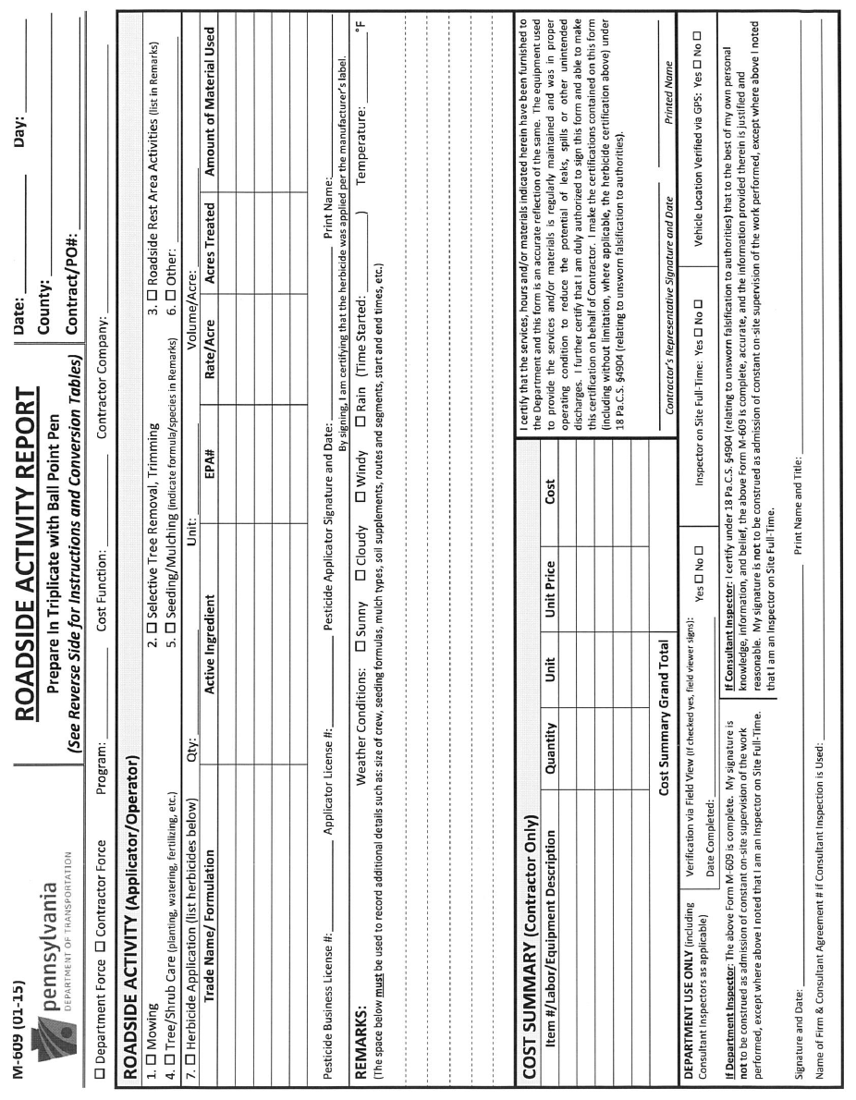

Attachment B, Confirmation of Services Report (OS-501)

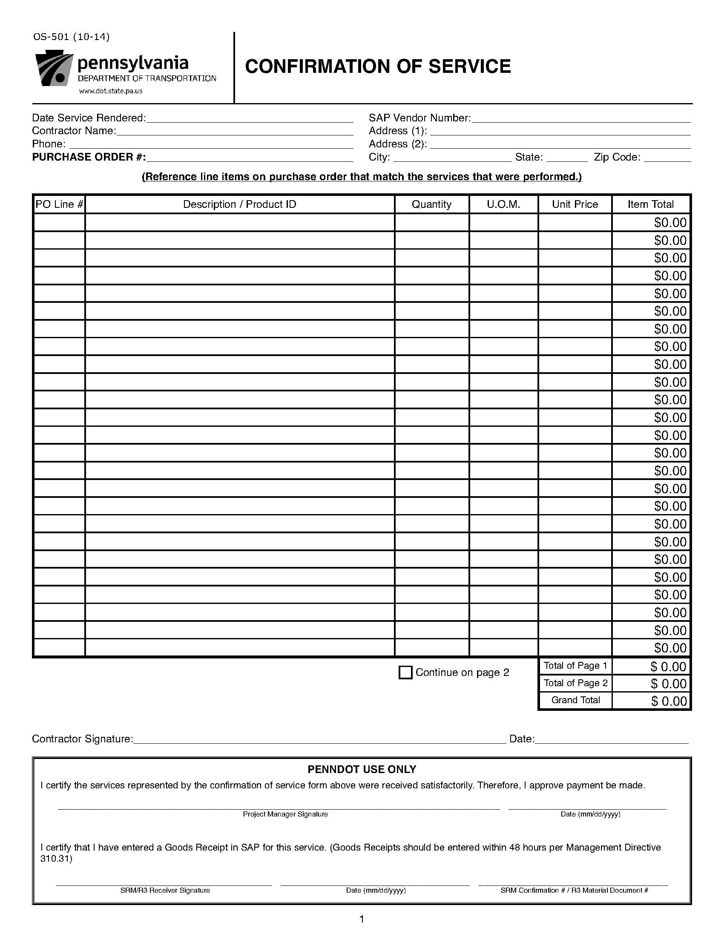

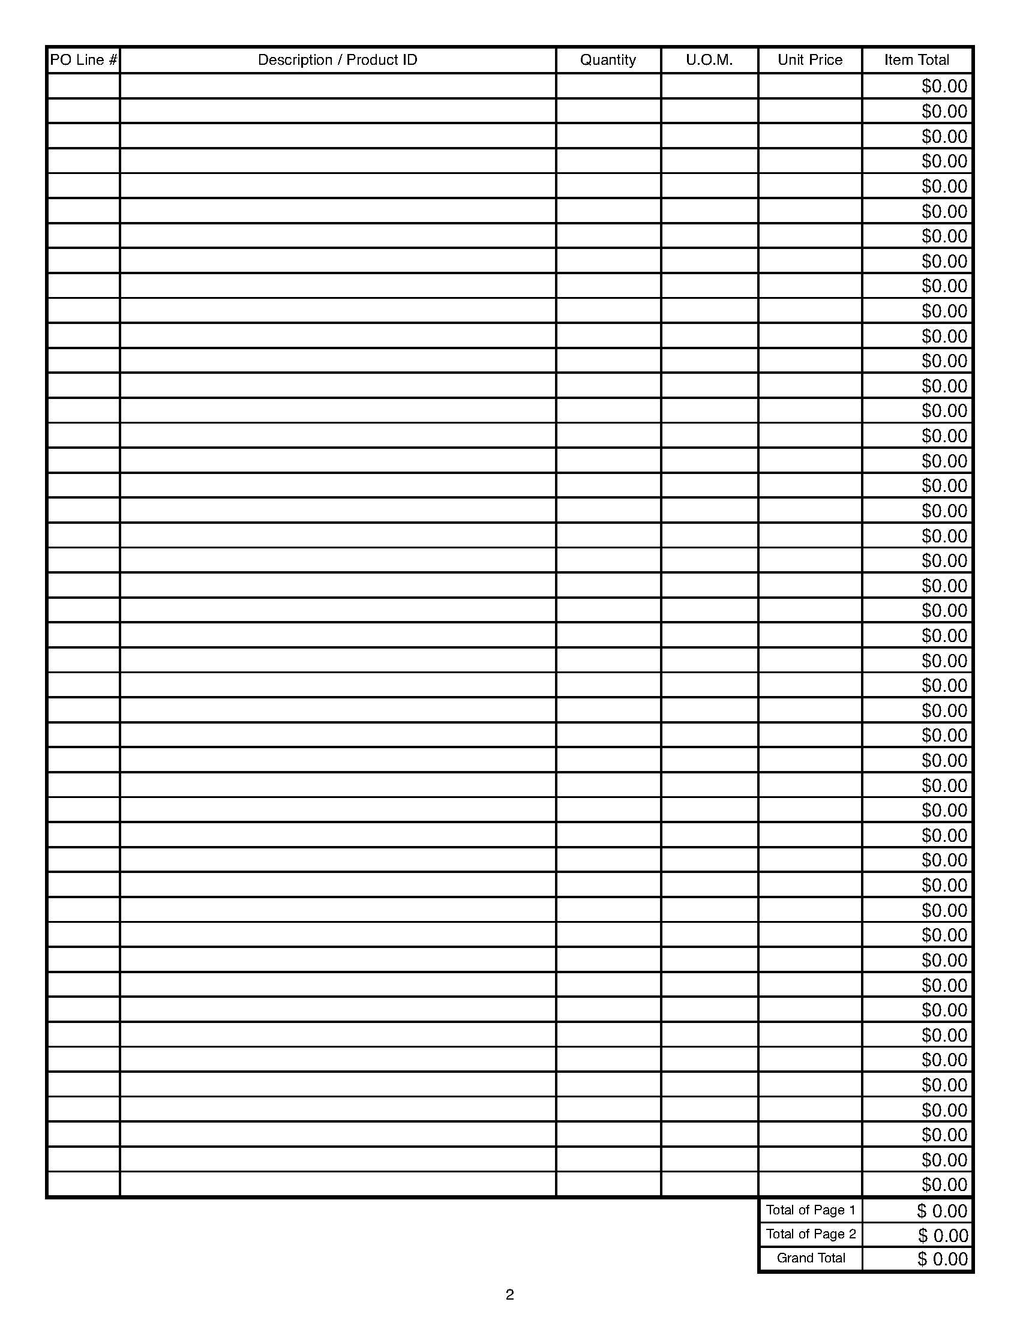

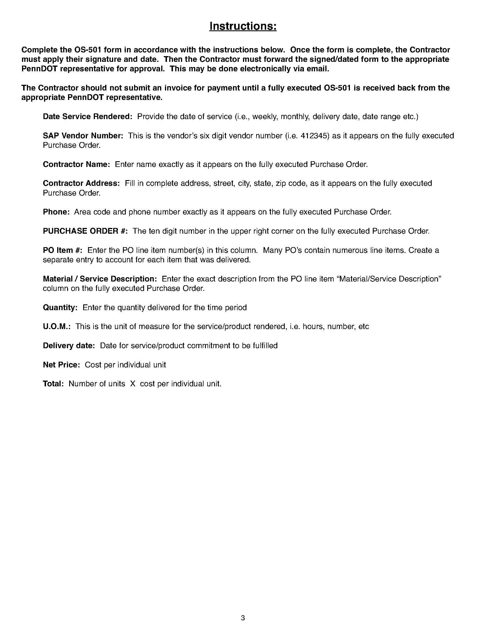
Attachment C, List of Vehicles and Equipment

(List Only the Vehicles and Equipment that will be used for this Contract, including Work Zone Traffic Control Vehicles and Equipment)

License or Identification  Number | Purpose | Type of  Vehicle or Equipment | Capacity/Size | For PennDOT Use Only
 |  |  |  | Equipment Provided At Demonstration  (Pass/Fail) | Comments

Vehicles and equipment utilized for maintenance contract work must meet the requirements as described in the contract specifications and the laws and regulations of Pennsylvania. The Contractor hereby verifies that all vehicles and equipment in the above table as submitted with the bid is adequate and necessary for the contract maintenance work and all listed vehicles and equipment will be available at the initial demonstration. All vehicles and equipment in the above table shall be inspected and approved by PennDOT during the demonstration(s). Where a contractor intends to rent vehicles and equipment, the identification number or license number on the table above may be provided at the time of the initial demonstration; however, all remaining information for the rented vehicles and equipment must be provided in the table above with the bid. The Contractor agrees to maintain and, as applicable, update this list of all vehicles and equipment after start of work for the duration of the contract.
Name of Company: ______________________________________ Date:__________
For PennDOT Use Only:
• Initial or Second Demonstration: ___________ Date of Demonstration: ____________________
• Location of Demonstration____________________________________________________________
• By: ______________________________________________________________________________
• Overall Demonstration (Pass/Fail): __________________________________
• Demonstration Notes:________________________________________________________________
_________________________________________________________________________________________________________________________________________________________________________________________________________________________________________________________

Attachment D, PATA Figures

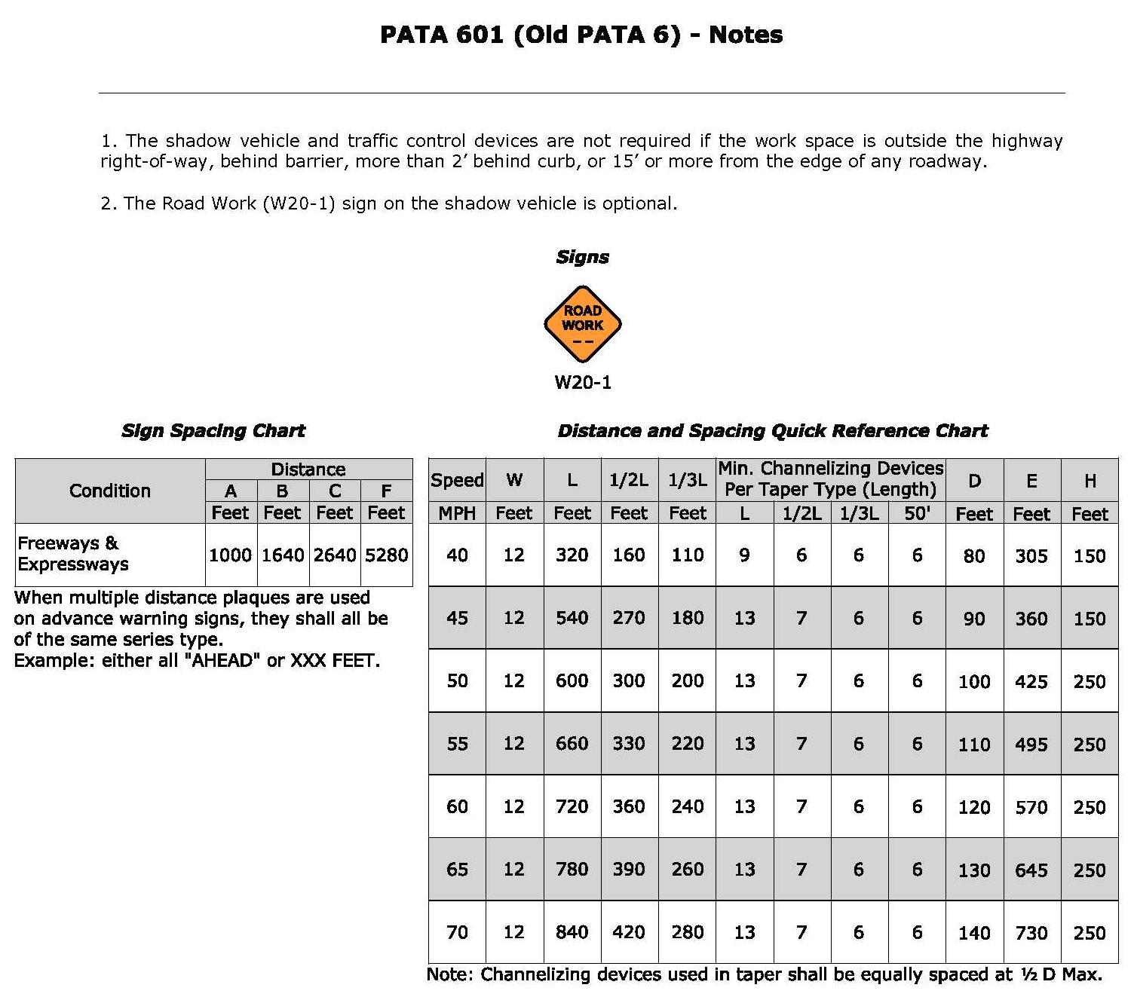
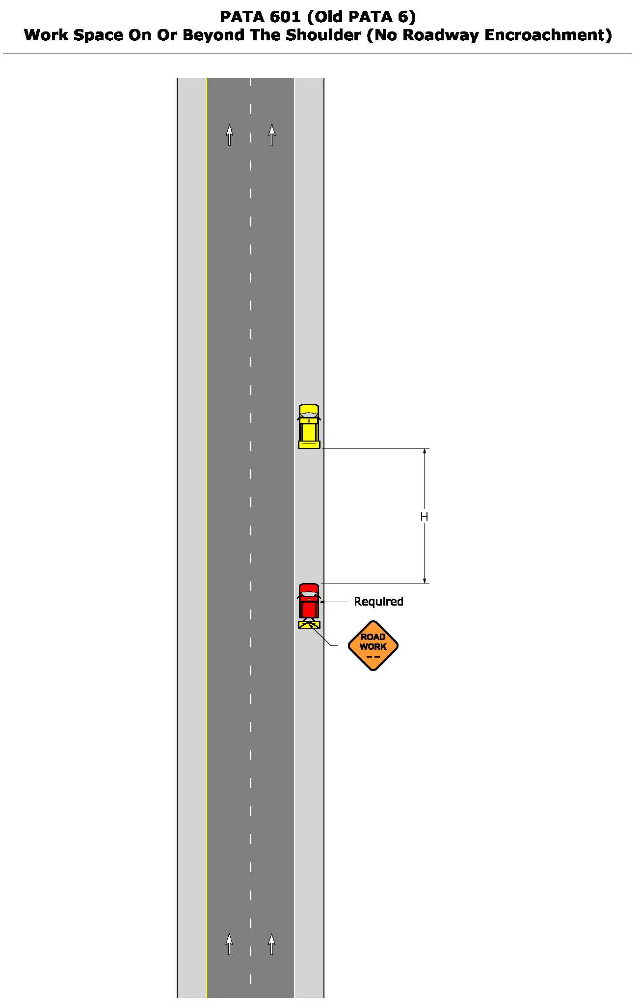

Attachment E, County Location Maps

Please refer to the following FTP site:

ftp://ftp.dot.state.pa.us/public/Bureaus/HighwaySafety/Maintenance%20Technical%20Leadership%20Division/Vendor%20Outreach/

Attachment F, Tabulation of Quantities

PART 1 – MONTGOMERY COUNTY
State route numbers, segments, offsets and video (videolog) information can be found at:
http://www.dot7.state.pa.us/PavementHistory

Summary of Bid Items
Item Numbrer | Description of Item | Estimated Quantity | Unit of Measure
1 | Mowing | 4 | Cycle
2 | Mowing-As directed | 23 | Acre
3 | WZTC | 4 | Cycle

Reference List
Item | Route | Begin  Seg/Off | End  Seg/Off | Miles  (X.XX) | Acres | # of  Cycles
1 | 76 | 3270/0000 | 3390/2852 | 12.52 | 3.93 | 4
2 | 8002 | 10/0000 | 10/0688 | 0.13 | 0.13 | 4
3 | 8002 | 510/0000 | 510/0533 | 0.1 | 0.4 | 4
4 | 8002 | 260/0000 | 260/1659 | 0.31 | 0.47 | 4
5 | 8002 | 250/0000 | 250/1620 | 0.31 | 0.57 | 4
6 | 8002 | 20/0000 | 20/0461 | 0.09 | 0.2 | 4
7 | 8002 | 750/0000 | 750/1186 | 0.22 | 0.96 | 4
8 | 9412 | 10/0000 | 10/2959 | 0.56 | 0.2 | 4
9 | 8004 | 500/0000 | 500/1890 | 0.36 | 0.7 | 4
10 | 8004 | 260/0000 | 260/2250 | 0.43 | 0.75 | 4
11 | 8004 | 250/0000 | 250/0369 | 0.07 | 0.03 | 4
12 | 8004 | 10/0000 | 10/1460 | 0.28 | 0.88 | 4
13 | 8004 | 20/0000 | 20/1271 | 0.24 | 0.87 | 4
14 | 8006 | 10/0000 | 10/0265 | 0.05 | 0.32 | 4
15 | 8006 | 260/0000 | 260/0823 | 0.16 | 0.37 | 4
16 | 8006 | 750/0000 | 750/1397 | 0.26 | 0.46 | 4
17 | 8006 | 510/0000 | 510/1418 | 0.27 | 0.04 | 4
18 | 8006 | 530/0000 | 530/1221 | 0.23 | 0.46 | 4
19 | 8006 | 270/0000 | 270/0740 | 0.14 | 0.4 | 4
20 | 8016 | 510/0000 | 510/1499 | 0.28 | 0.5 | 4
21 | 8008 | 750/0000 | 750/0440 | 0.08 | 0.55 | 4
22 | 8008 | 500/0000 | 500/1390 | 0.26 | 0.48 | 4
23 | 8010 | 10/0000 | 10/0525 | 0.1 | 0.2 | 4
24 | 8010 | 750/0000 | 750/0370 | 0.07 | 0.07 | 4
25 | 8010 | 500/0000 | 500/0429 | 0.08 | 0.04 | 4
26 | 8010 | 250/0000 | 250/0430 | 0.08 | 0.04 | 4
27 | 8012 | 10/0000 | 10/1238 | 0.23 | 0.06 | 4
28 | 8012 | 20/0000 | 20/0502 | 0.1 | 0.1 | 4
29 | 8012 | 30/0000 | 30/1324 | 0.25 | 0.36 | 4
30 | 8012 | 250/0000 | 250/0666 | 0.13 | 0.06 | 4
31 | 8012 | 260/0000 | 260/0458 | 0.09 | 0.13 | 4
32 | 8016 | 500/0000 | 500/1350 | 0.26 | 0.6 | 4
33 | 309 | 70/0000 | 270/0000 | 10.11 | 5.27 | 4
34 | 8039 | 500/0000 | 500/0615 | 0.12 | 0.36 | 4
35 | 8039 | 250/0000 | 250/0645 | 0.12 | 0.05 | 4
36 | 8039 | 10/0000 | 10/0650 | 0.12 | 0.22 | 4
37 | 8039 | 750/0000 | 750/0479 | 0.09 | 0.13 | 4
38 | 8037 | 500/0000 | 500/0639 | 0.12 | 0.11 | 4
39 | 8035 | 250/0000 | 250/0679 | 0.13 | 0.19 | 4
40 | 8035 | 10/0000 | 10/0372 | 0.07 | 0.32 | 4
41 | 8033 | 250/0000 | 250/0990 | 0.19 | 0.2 | 4
42 | 8033 | 10/0000 | 10/0605 | 0.11 | 0.14 | 4
43 | 8029 | 250/0000 | 250/0620 | 0.12 | 0.06 | 4
44 | 8029 | 10/0000 | 10/1050 | 0.2 | 0.07 | 4
45 | 8029 | 750/0000 | 750/0570 | 0.11 | 0.08 | 4
46 | 8029 | 500/0000 | 500/0645 | 0.12 | 0.12 | 4
47 | 8027 | 500/0000 | 500/0726 | 0.14 | 0.16 | 4
48 | 8027 | 250/0000 | 250/0674 | 0.13 | 0.24 | 4
49 | 8027 | 10/0000 | 10/0784 | 0.15 | 0.15 | 4
50 | 8027 | 750/0000 | 750/0480 | 0.09 | 0.06 | 4
51 | 8025 | 500/0000 | 500/0931 | 0.18 | 1.02 | 4
52 | 8025 | 250/0000 | 250/0770 | 0.15 | 0.61 | 4
53 | 8025 | 20/0000 | 20/1135 | 0.21 | 1.72 | 4
54 | 8025 | 750/0000 | 750/0708 | 0.13 | 1.24 | 4
55 | 422 | 90/0000 | 340/2565 | 14.3 | 118.44 | 4
56 | 8023 | 10/0000 | 10/1560 | 0.3 | 0.5 | 4
57 | 8023 | 260/0000 | 260/2795 | 0.53 | 0.24 | 4
58 | 8023 | 500/0000 | 500/1333 | 0.25 | 0.65 | 4
59 | 8015 | 10/0000 | 10/1575 | 0.49 | 0.49 | 4
60 | 8015 | 260/0000 | 260/1061 | 0.2 | 0.26 | 4
61 | 8015 | 500/0000 | 500/0316 | 0.06 | 0.77 | 4
62 | 8015 | 250/0000 | 250/0904 | 0.17 | 0.81 | 4
63 | 8013 | 750/0000 | 750/0939 | 0.18 | 0.54 | 4
64 | 8013 | 760/0000 | 760/1426 | 0.27 | 2.2 | 4
65 | 8013 | 500/0000 | 500/0745 | 0.14 | 1.64 | 4
66 | 8013 | 250/0000 | 250/0906 | 0.17 | 1.1 | 4
67 | 8011 | 10/0000 | 10/1118 | 0.21 | 1.74 | 4
68 | 8011 | 750/0000 | 750/0800 | 0.15 | 1.87 | 4
69 | 8011 | 500/0000 | 500/0965 | 0.18 | 1.51 | 4
70 | 8011 | 250/0000 | 250/1053 | 0.2 | 1.57 | 4
71 | 8009 | 10/0000 | 10/0810 | 0.15 | 0.9 | 4
72 | 8009 | 750/0000 | 750/0785 | 0.15 | 1.06 | 4
73 | 8009 | 500/0000 | 500/0912 | 0.17 | 1.35 | 4
74 | 8009 | 250/0000 | 250/0740 | 0.14 | 1.37 | 4
75 | 8007 | 10/0000 | 10/1599 | 0.3 | 3.78 | 4
76 | 8007 | 30/0000 | 30/1051 | 0.2 | 0.23 | 4
77 | 8007 | 500/0000 | 500/0928 | 0.18 | 0.42 | 4
78 | 8007 | 250/0000 | 250/1175 | 0.22 | 1.5 | 4
79 | 8005 | 750/0000 | 750/0755 | 0.14 | 1.09 | 4
80 | 8005 | 770/0000 | 770/1615 | 0.31 | 5.84 | 4
81 | 8005 | 500/0000 | 500/1099 | 0.21 | 2.25 | 4
82 | 8005 | 250/0000 | 250/1162 | 0.22 | 0.5 | 4
83 | 8003 | 10/0000 | 10/1461 | 0.28 | 2.04 | 4
84 | 8001 | 10/0000 | 10/0890 | 0.17 | 0.77 | 4
85 | 8001 | 750/0000 | 750/0828 | 0.16 | 0.32 | 4
86 | 8001 | 510/0000 | 510/1030 | 0.2 | 2.37 | 4
87 | 8001 | 500/0000 | 500/0692 | 0.13 | 0.45 | 4
88 | 8001 | 250/0000 | 250/0839 | 0.16 | 0.51 | 4
89 | 152 | 250/0000 | 250/0839 | 0.33 | 0.77 | 4
90 | 100 | 10/0000 | 130/1047 | 7.08 | 10.27 | 4
91 | 8028 | 750/0000 | 750/0775 | 0.15 | 0.34 | 4
92 | 8030 | 10/0000 | 10/0697 | 0.13 | 0.03 | 4
93 | 8030 | 750/0000 | 750/0570 | 0.11 | 0.18 | 4
94 | 8030 | 500/0000 | 500/0340 | 0.06 | 0.37 | 4
95 | 8030 | 250/0000 | 250/0726 | 0.14 | 0.02 | 4
96 | 8032 | 750/0000 | 750/0622 | 0.12 | 0.14 | 4
97 | 8032 | 500/0000 | 500/0650 | 0.12 | 0.19 | 4
98 | 8032 | 250/0000 | 250/0608 | 0.12 | 0.03 | 4
99 | 8032 | 10/0000 | 10/0640 | 0.12 | 0.18 | 4
100 | 4031 | 270/1157 | 280/1568 | 0.33 | 0.53 | 4
101 | 663 | 340/1421 | 374/1531 | 1.33 | 4.96 | 4
102 | 23 | 210/0000 | 220/0000 | 0.18 | 1.75 | 4
103 | 8017 | 500/0000 | 500/0890 | 0.17 | 0.38 | 4
104 | 202 | 80/0000 | 100/2662 | 1.2 | 2.06 | 4
105 | 202 | 10/0000 | 30/0000 | 0.66 | 0.86 | 4
106 | 476 | 0142/000 | 0194/0800 | 5.49 | 18.4 | 4
107 | 8006 | 0250/0000 | 0250/1651 | 0.31 | 0.1 | 4
108 | 8006 | 0280/0000 | 0280/2100 | 0.4 | 0.29 | 4
109 | 8006 | 0500/0000 | 0500/0794 | 0.15 | 0.31 | 4
110 | 8006 | 0760/0000 | 0760/1386 | 0.26 | 0.06 | 4
111 | 8014 | 0010/0000 | 0010/1595 | 0.3 | 0.82 | 4
112 | 8014 | 0020/0000 | 0020/1362 | 0.26 | 0.9 | 4
113 | 8014 | 0250/0000 | 0250/0734 | 0.14 | 0.09 | 4
114 | 8014 | 0500/0000 | 0500/0870 | 0.16 | 0.43 | 4
115 | 8014 | 0510/0000 | 0510/1114 | 0.21 | 0.43 | 4
116 | 8014 | 0750/0000 | 0750/0495 | 0.09 | 0.13 | 4
117 | 8024 | 1010/0000 | 0010/0947 | 0.18 | 0.23 | 4
118 | 8024 | 0250/0000 | 0250/0450 | 0.09 | 0.1 | 4
Part 1 - Total |  |  |  | 73.33 | 234.28

Attachment G, Standard Limits of Mowing



